M3D2
• Research on the internet the following:
- High efficiency televisions
- High performance windows
- High efficiency clothes washers
- High efficiency water heaters
• Write a short statement on each of these products describing the increase in efficiency as well as technically how this increase in efficiency was achieved. Also state whether you would consider purchasing these products and why.

How have modern energy-efficient televisions, windows, clothes washers, and water heaters lowered energy consumption?
- High Efficiency Televisions – LED and LCD Televisions are considered the latest in High Efficiency. Other significant improvements over the old Cathode Ray Tube models include Plasma Displays and Rear Projection Televisions. All the “current technology” televisions tend to come in sizes larger than CRTs, which were rarely larger than 40 inches. Plasmas are actually more energy-consuming than a CRT of similar size, and get worse, because of their usually being in the 55-60 inch range. Interestingly, www.conservingelectricity.com says the, “National Resources Defense Council (NRDC) study estimates that energy used by television and related peripherals accounts for as much as 10 percent of the electric bill in a typical American home.” I have not replaced the 34” HD monitor I bought seven years ago, so will soon buy a new 60” or larger flat screen – probably a LED/LCD hybrid type, or, more likely, a modern projection system. Energy use is so close as to be a non-factor in this choice, but for the record, projection sets tend to be the most energy efficient on average. However, I will choose for high resolution and disregard energy use, because in my home the performance is more important than saving three dollars a year, especially when the objective in this extra savings (buying an EnergyStar rated set) is to satisfy some deluded global warming enthusiast in Washington, DC.

- Windows – Low E Glass works to reduce energy consumption by using a filter to reflect heat back to its source while transmitting visible light through the pane. “Long wave radiation energy is heat, and short wave radiation energy is visible light from the sun.” Generally low-e windows cost between 10 percent and 15 percent more than standard. The reduction in energy loss can be 30 percent to 50 percent. (Low-E Glass, n.d.) 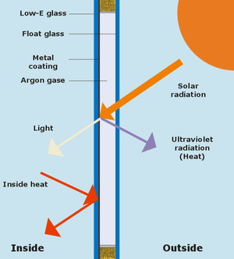
In 2005, I installed Low E tempered glass double-lifetime warrantied windows in my house in Maine. The old windows allowed ultraviolet radiation deterioration of draperies and flooring inside the house as well as transmitting heat at an unacceptable rate. We only lived in the house another year before turning it to a rental, but realized savings in our energy use (we went from burning 8 cord to 7 cord of hardwood per year to keep the house comfortable), in our personal comfort and usable space (we could sit in front of the three south-facing windows in summer sunshine where it was too hot to remain there with the old windows – the builder said he had measured temperatures over 100 degrees Fahrenheit with the ambient temperature around 80 degrees where, after installing the new windows, never felt anything above 80 degrees), and in preservation of things like draperies, flooring, and upholstery. Developed by commercial interests in Great Britain and Germany, Low E glass is a party the US government came typically late to. I would/will continue using this technology wherever possible to increase efficiency and preserve precious things within the window.

- High Efficiency Clothes Washers – Encouraging consumers to add to the waste stream plaguing the US by disposing of properly functioning equipment that happens to pre-date government efforts to abate the impending Global Warming Disaster that will melt the planet by the end of 2012, EnergyStar advocates everyone in the US purchasing a new EnergyStar rated washing machine and throwing their old one in the trash. This may well have been done to appease big business lobbyists for appliance manufacturers like General Electric, whose CEO is an economic advisor to the POTUS. Research is in progress. The EnergyStar website claims that, “If every clothes washer purchased in the U.S. this year earned the ENERGY STAR, we would save 540 million kWh of electricity, 20 billion gallons of water, and 1.4 trillion BTUs of natural gas every year, resulting in energy bill savings of about $250 million, every year.” (Clothes Washers for Consumers, n.d.) If we all run out and buy EnergyStar rated machines, each household in America (115,226,802 households according to the latest census) can save $2.17 over a year of use. They’ll recoup their cost in what? 250 years, so that will be OK. But General Electric and other crony capitalist companies who comply with the new fascist efficiency standards stand to gain handsomely as consumers bow at the altar of government advice to waste well-functioning and easily maintained machines we have used for years. This was really worth our tax dollars supporting the bloated EnergyStar organization, wasn’t it? This is government efficiency on par with the $600.00 toilet seat, Cash for Clunkers, and Green Jobs, and Jeff Immelt’s shipping of lightbulb manufacturing jobs overseas while proclaiming that US businesses needed to stop sending jobs overseas. (By the way, we live in a house provided and provisioned for us by my company. Our European highly efficient laundry machines (washer and drier) require two or three runs to achieve acceptable cleanliness and dryness on a par with the old (pre-1998) machines we use stateside. This means at a 30% energy savings per load, our energy use only went up 20% to 80% for switching to a High Efficiency washer. Thanks, EnergyStar and associated government solutions. I’ll take free market capitalism, thank you very much. I will shop for machines that do the job right the first time and not for a moment consider the crony-capitalist/fascist EnergyStar advice on washing machines.

- High Efficiency Water Heaters – Water heaters come in four flavors; Tank, Demand, Heat Pump, and Solar (or Geothermal) with power-assist backup. Tanks store water and have a burner (usually gas or oil, but sometimes wood or coal) or electric heating element that heats the water in the tank. High Efficiency in these usually indicates more than historically normal R Value in insulation, but can indicate better heat transfer or generating mechanisms. Demand water heaters are usually gas or electric, and operate by passing water flow through an array of heated elements – usually a coil of copper pipe with a burner or heat element inside the coil. A heat pump trades heat from cooler and warmer ambient systems, accumulating heat in a storage tank. Savings in direct costs for running the heating element of powered-heat systems can, especially in moderate or cool climates, be overcome by extended pump run times. Cost savings are usually posted against electric resistance heating systems which tend, like their home heating furnace cousins, to be far less efficient than locally oil or gas-burning systems of similar size; so the savings appears high, but when gauged on comparisons with all other methods, is highly dependent on climate at best. Solar with electric backup is billed as the highest savings method of heating water, but this discounts high startup costs including installing and keeping operational a complete backup system to take over in case hot water is desired after dark or on a cloudy day. The typically myopic EnergyStar website offers this spreadsheet with their savings calculated:
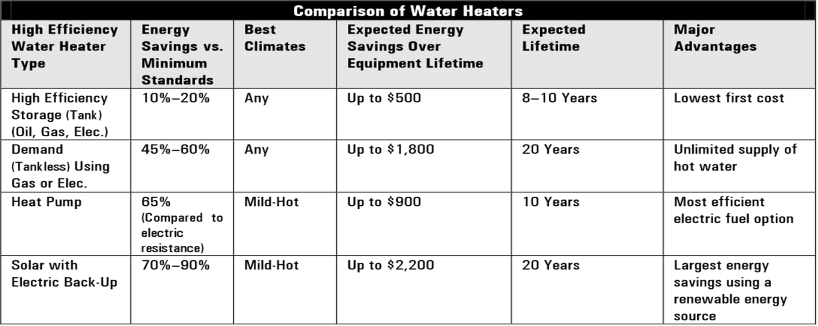
Better efficiency in water heaters seems to be mostly in reducing heat loss endemic in older water heaters. By using heated water shortly after heating or better preserving the heat by better insulation, more efficiency can be realized. Better insulation can be done with older water heaters more cheaply and with far less waste than disposing of older models and replacing them with newer ones. Older models tend to have thicker metal walls and more robust heating elements, being built to maintain and provide many years use. Modern models are more wasteful in that their heating elements and piping or tanks are made from lighter material that will not survive maintenance and so must be discarded when problems occur.
I will purchase demand water heaters that burn propane or natural gas because of their convenience and the abundance of low cost fuel available. I will also use geothermal source warming for preconditioning water, because this is a method of reducing the BTU’s required to heat to desired levels, and therefore constitutes true savings.

- chair of the President’s Council on Jobs and Competitiveness

BIBLIOGRAPHY
Lau, P. (n.d.) The key to the led tv devolpment is high-efficiency components, Retrieved from http://ezinearticles.com/?The-Key-to-the-LED-TV-Development-Is-High-Efficiency-Components&id=6096401
Most Efficient TVs (2012) Energy star most efficient 2012 – televisions, Retrieved from http://www.energystar.gov/index.cfm?c=most_efficient.me_tvs
Low-E Glass (n.d.) Retrieved from http://www.wisegeek.com/what-is-low-e-glass.htm
Low Emissivity Argon Gas (n.d.) Retrieved from http://www.uniquefoldingdoors.com/Products.html
Clothes Washers for Consumers (n.d.) Retrieved from http://www.energystar.gov/certified-products/detail/clothes_washers
High Efficiency Water Heaters (n.d.) Retrieved from http://www.energystar.gov/ia/new_homes/features/WaterHtrs_062906.pdf

