Dad,

I have had a whacky idea rattling around for some years now and wonder if you'll help me with it? I think I mentioned this, but have not gotten farther than some rudimentary modeling and brainstorming exercises. I cannot seem to get a product across the finish line for lack of time. It is a fluid-based thermo-electric heating and cooling suit, and I wonder if I could send you some components, would you be a Systems Prototype Engineer?

The initial concept came from your issue with circulation to your extremities. The easy answer to heating is a productized electric suit featuring socks, gloves, pants, and jacket. The most prevalent manufacturer is Gerbings, and they are regularly seen on BMW motorcyclists who have near-unlimited budgets. The cost for a full Gerbings outfit is well over $1000.00 with all the shells. The biggest drawback to these suits is that they provide heat only. I think we can do better.

When I began mulling this idea over and shying away from the expense, I was riding my bike around in the Virginia summer and concerned with my body temperature going up, but a perceived need (that would prove life-saving) to wear ATGATT (All The Gear, All The Time). I had a thermo-electric cooler/heater that I used in my truck to keep drinks cool or warm up leftovers, and began toying with that as a source for heating and cooling a body. The final push to follow a heat/cool path came when one of my fellow engineers told me her dad suffered from Multiple Sclerosis, and had to carry a bucket of ice around wherever he went out in the summer, and have an electric blanket around just in case he spiraled out of control the other thermal direction. Either way, he was tethered to a house wall socket or an ice chest. Then there are military and other desert, polar, mountain, and tunneling or caving access applications, some of which my work makes me highly aware.

Illustration 1: Peltier Effect ThermoElectric Divice

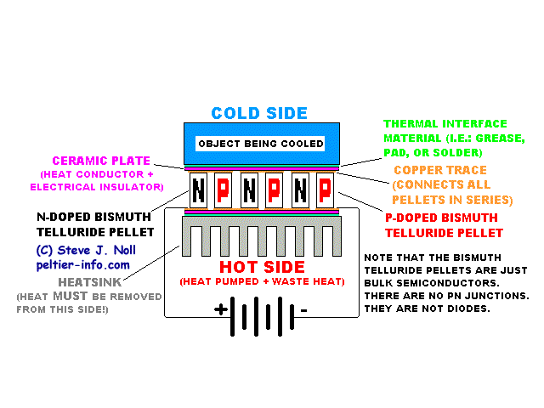 The thermo-electric device (TED, or Peltier Effect Device – Illus. 1) is a ceramic-coated metallic component usually configured in a flat package, most commonly being 40mmX40mm and about 3/16” thick. It has red and black 28awg (or so) stranded copper insulated DC power leads potted to the device. This is the device embedded in the heater/coolers that have flooded markets in the past few years. Under DC voltage, one side gets hot and the other gets cool, so it is a heat exchanger, driven by input power. Changing polarity changes which side is hot and which is cool. Another interesting characteristic is that these can work in reverse; meaning inducing heat on one side and relative cool on the other, one may take a DC electric charge from the wires, polarity driven by which side is hot and which is cooler. But we'll talk about scavenging heat differentials as a power source later, if this plot bears fruit..

A secondary benefit is that temperature can be controlled in a variety of ways. First, a system could be hard-wired and engineered to provide a given amount of heating or cooling based on the caloric output of the wires at designed voltage. Second, temperature can be controlled by a user with Vernier controls like those used with the Gerbings suits (Illus. 2.) – a potentiometer turns up or down the heating based on how the wearer feels, with no concern for the actual temperature of the wires. The potentiometer is built to not over-power the wires in the suits, and not to get hot enough to burn a person. By a simple coaxial switch, polarity can be changed and this controller could be used to heat or cool with the TED. I’ve modeled it with a TED, and demonstrated this effect. This controller has been purpose-designed to handle some 65 Watts, which will power TEDs of sufficient size and power to provide a fair among of heating or cooling. They can be purchased in single or double (pictured) pots, which are usually used for separate upper (shirt and gloves) and lower (pants and socks) control. Thirdly, and I think this has the most merit for my wild scheme, a heating and cooling digital thermostat (Illus. 3) can be used to set a temperature and internally switch polarities to provide heating or cooling on demand.

Illustration 2: Gerbings(TM) Dual

Potentiometer Controller

So we can heat or cool a cup of coffee. Big deal. This has been done by mere mortals for years. Distributing the heating and cooling effect to fingers and toes (or other places as desired) is the challenge here. My brilliant notion was first to circulate water, and this worked great in my initial modeling, but better science suggests ethylene glycol or perhaps Schnake Bite Medicine or something would be a better choice in order to not get frozen in the winter, to prevent biological growth in the tubing, and maybe provide apre-ride refreshments (though not with the ethylene, of course – the popular fluorescent dyes could make your eyes look strange).

Illustration 3: Digital ThermoElectric Device Controller

A design consideration I wrestle with is that the system needs to be unobtrusively wearable. It should produce a good effect and not be cumbersome, as a bucket of ice and chill-vest or home AC outlet presently are for MS patients. Those poor people must sit next to their ice chest and wear a vest that looks like a science experiment bought from WalMart gone wrong. The Gerbings suits are presentable in public and even unobtrusive as far as being styled to wear while riding and allowing manual dexterity. I am jealous of their small filament making the circuit up and down fingers and with the controller on a belt pack, connected by a coaxial plug to the bike or snowmobile's DC outlet or even a take-along lithium battery. Wearers should be able to participate in physical activities while enjoying the benefits of the suit, and ultimately swap out common 12V lithium batteries for truly portable operation – although this battery application is not for the beta (prototype), but maybe part of a more marketable Version 1.0 as an added-cost upgrade. (I see where we integrate a charger and keep the battery onboard as a common battery backup feature, plugged in or not – or even removable.)

So the tubes to the fingers and toes must be small enough to fit inside over-gloves or embedded within the felt liners of boots, the heat transfer unit should be able to fit on the back or shoulder(s), and the controller (and eventually battery adapter) should be able to mount on a belt pack, in a discrete vest pocket or armband for convenient accessibility and on-the-go temperature adjustment. Two considerations must be answered for, as regards the tubes. First, heat transfer should be optimized - prevented in transit from the heat transfer device and reservoir and concentrated at desired places (finger and toe tips, the torso area, the head (thinking of race car drivers' or football players' helmets here), or other things by personal preference. Second, the tubing needs to be flexible enough to allow unmolested movement yet robust enough to ensure the flow path remains open and connected while the wearer bends and stretches repeatedly.

I've proven I can pump heated or cooled liquid around a simple Tygon tubing circuit from a ½ liter tank using a TED potted between a hard disk drive water block (a copper heat transfer block with water channels through it) on one side and cooling fins on the other with 3/8” ID tubing, and I even split the flow once, though I did not use flow control to ensure even distribution – and I think that must be part of any productized system. The heating/cooling circuit I built is no great feat, as liquid cooling systems are relatively common for PCs, as there are on-going issues with heat generated by microprocessors used as main CPUs and high-end video cards. Also, circulating around five fingers poses a challenge in a manifold or allowing one end first crack at the conditioned (heated or cooled) thermal liquid and leaving others with the leftovers.

Illustration 4: Pre-packaged CPU Cooling System

A couple of off-the-shelf solutions come to mind and should be considered. I've nearly bought a CPU cooling system (Illus. 4) for a modeling device as it would provide most of the components already integrated into a relatively clean package that could be strapped on like a backpack or even integrated onto a backpack or a shoulder/upper arm attachment. Also, for MS patients and other temperature control cases, some interesting water flow pads like the booties shown (Illus. 5) as well as some flat flow pads (Illus. 6) are being produced, though these are for sedentary life, and I’d like to make rigorous activity possible while suited up.

It may make sense to incorporate some of these anatomically-designed pads, however I am not sure how they would perform a) with heat (they are designed for cooling) and b) in an active environment where the user may pinch or block flow.

Illustration 5: Water Cooling Booties

I'd like to build something shell-agnostic, like a suit of underwear with tubing and flow pads integrated and zero-drip connectors for the tubing. One could ideally choose their favorite pack boots or eventually even some more stylish, less bulky shoes, for instance, and put in a purpose-built liner or sock with the flow tubing designed into it. For motorcyclists and those who want the cooling effects, a breathable boot may need to be designed with water channels and heat transfer elements, especially in the toes, but again that would be a production model – pack boots and flow-enabled liners would prove the concept for prototype, and get you on a snowmobile more often. A glove liner for chopper mitts or glove over-shells can be fitted with tubing and heat transfer elements stitched on the backs of the fingers. Gloves could eventually be made of foam; like ski gloves, motorcycle gloves, or high-end work gloves with the armoring on the outside and the tubing integrated into the shell, but that, too, is an idea for production, not prototype.

Illustration 6: Water Cooling Body Wrap

For prototype (Illus. 7), I see a manifold for distribution to capillaries. Prices for common cooling water manifolds are astronomical and generally metal, so I've opted for an inexpensive push-to-connect fitting that only has three possible outputs (Illus. 8). The smaller two fingers will be on a common loop. The manifold mounts on the forearm or back of the hand to split from the 3/8” ID feed down to 1/8” ID individual finger lines. This can be tried with just the plastic tubing, but my drawing suggests positions for copper radiating elements at desired points. These copper pieces will need to be manufactured from soft copper tubing, and the bends and getting reliable connections between the copper and flexible plastic tubing will be tricky. I am including small hose clamps in the kit to enable some reliability on these connections under pressure and use.

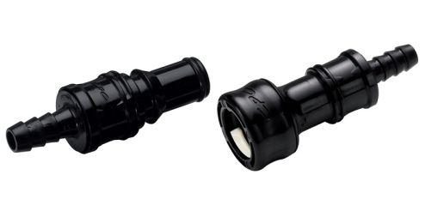Illustration 9: Dripless Quick Tubing Disconnect

Illustration 8: 3-Way Manifold

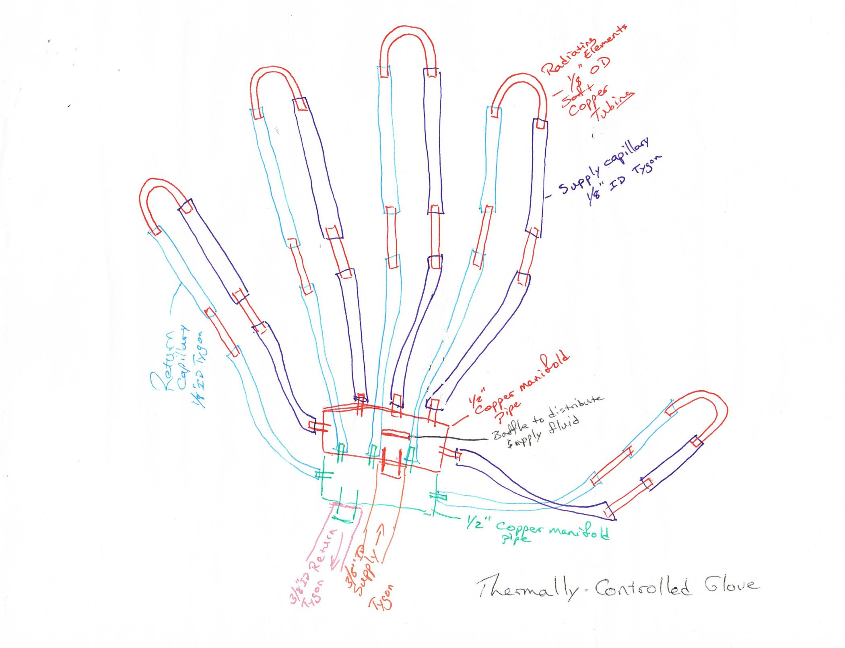Illustration 7: Thermally Controlled Glove Plumbing

The apparatus drawn in Illus. 7 is to be whip-stitched onto the back of a glove liner or the inside of a chopper mitt; and, if part of the liner, should be low enough profile to allow free movement and fit inside a shell mitten or, ideally, an over-glove. At the wrist are inlet and outlet dripless quick-disconnect adapters to connect the glove to the jacket. These connectors (Illus. 9) will break apart with sufficient tension and automatically stop flow when disconnected. These are 3/8” ID connectors at the gloves and another will be at the waist of the jacket for the boots – the trousers get reducing Ys to go from 3/8” input to 1/4” for the flow around the foot and back to 3/8” again to connect to the jacket where the reservoir and heat transfer device are resident.

I have specified a $50.00 drive-bay reservoir/water block combination from a PC cooling system (this would do away with the need for a water block, if it can handle heat), but I’m looking for options. Bicyclist’s water bottles on a belt or some such thing may be a better option, for ruggedness and ergonomic form-fit to facilitate activities. Another possible option I've thought of is a CamelBack-type hydration pack (Illus. 10) soft bladder with a port drilled and mounted into the fill-cap at the top (as worn) for return fluid. This would have the added benefit of being a natural mounting/stowing 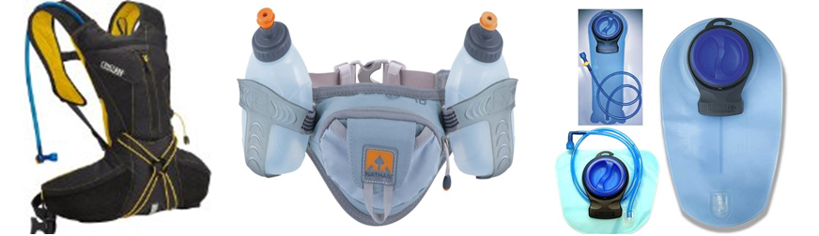point for the pump and heat exchanger, though to have it in a pack and not integrated into the jacket would require one more set of disconnects so the pack could be removed from the coat – and this may be desired or a requirement before this is productized. One consideration about this soft bladder is pressure in the system – a suddenly-inflated water bladder strapped to the back may make the backpack suddenly restrictive... Another option with this soft bladder or even a low-profile form-fit hard-sided PTFE tank would be to sew it directly into a jacket or jacket liner, or make it snap in and out of a socket. While looking for bladder options, I came on the Camelbak Veloback, a shirt with a water bladder built in for cyclists. This may be fodder for imagination and it is therefore worth viewing the tradeshow demo in this video <http://www.youtube.com/watch?v=fJkMBvh8qy4> from time 3:55 to 6:40.

Illustration 10: CamelBak style packs and bladders

Please let me know if you are interested in building this thing? If you'll review it for sanity and a bit of an eye for economy, I'll get the parts in the cut sheet on order to deliver to you. I think this would potentially benefit you, cyclists, soldiers and sailors, divers, Multiple Sclerosis and other thermal control patients, skydivers, pilots, snowmobilers, ice fishermen, lumberjacks, rangers, rescue responders, and adventurers.